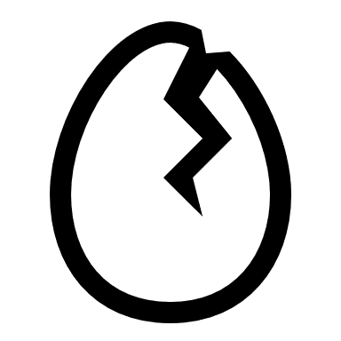**Egg Drop**

Our spy agency has managed to create a new emergency escape device inside of an egg. The moment you break the egg, smoke fills the room, allowing the spy to escape. However, we need some way of making sure the egg won’t break on transport!

Your mission: using the objects supplied to you, create some form of device that will cushion the egg from impact, so that it won’t be harmed! We will test this by dropping the egg from high up, and seeing if it survives the fall.

Before you can start on making your protection device, you must first complete this worksheet and plan out what you will do, then get it approved by your teacher.

Materials:

* 10 x straws
* 1 x sheet of newspaper
* 5 x pipe cleaners
* 1 x plastic cup
* 1 metre of masking tape

Aim:  
________________________________________________________________

________________________________________________________________

Hypothesis:

If_______________________________________________________________

Then____________________________________________________________

In the box below, sketch the design you plan on using. Remember to include labels

Results:

________________________________________________________________

________________________________________________________________

________________________________________________________________

How could you improve your design?

________________________________________________________________

________________________________________________________________

________________________________________________________________

________________________________________________________________

Conclusion:

________________________________________________________________

________________________________________________________________